# Mathematics Essential

# Name: ______________________

## Task 1.5 – Unit 1

**Assessment type:** Response - Skills

**Conditions:**

Time for the task: 15 minutes

In class, calculator permitted

**Marks:** 18 marks __________/18

**Task weighting:**

2% of the school mark for this unit

_________________________________________________________________________________

1. Estimate the capacity of each of the following (using mL, L or kL):
2. The classroom
3. Your school bag
4. The photocopy paper box on my desk
5. The bottle on my desk
6. a) Round $21.3598 to the nearest cent

b) Round $21.3598 to the nearest 5 cent

c) Round $21.3598 to the nearest dollar

d) Round $29.4589 to the nearest dollar

3. Find  
 a) What percentage of $320 is $80

b) What percentage is 5 cm of 2m

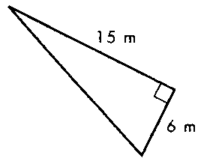

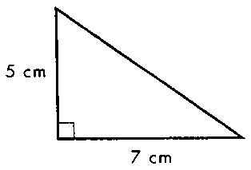4. Find the area of these two triangles?  
a)

b)

5. a) 5.5 days is how many minutes?

________________ minutes

b) March, April & May – how many days?

________________ days

6. a) Write in your own words the meaning of Salary as a method of payment

b) Write in your own words the meaning of Wages as a method of payment

# Mathematics Essential **Solutions**

## Task 1.5 – Unit 1

**Assessment type:** Response - Skills

**Conditions:**

Time for the task: 15 minutes

In class, calculator permitted

**Marks:** 18 marks ______________/18

**Task weighting:**

2% of the school mark for this unit

_________________________________________________________________________________

1. Estimate the capacity of each of the following (using mL, L or kL):

a) The classroom

Will vary!!

10 x 7 x 3 = 210 m3 = 210 000kL ✓

b) Your school bag  
~ 20L ✓

c) The photocopy paper box on my desk  
~ 15L ✓

d)The bottle on my desk

~ size of bottle you use mL ✓

1. a) Round $21.3598 to the nearest cent

$21.36 ✓

b) Round $21.3598 to the nearest 5 cent

$21.35 ✓

c) Round $21.3598 to the nearest dollar

$21.00 ✓

d) Round $29.4589 to the nearest dollar

$29.00 ✓

3. Find  
 a) What percentage of $320 is $80  
  
25% ✓

b) What percentage is 5 cm of 2m

 2.5% ✓

4. Find the area of these two triangles?  
a)

= 17.5 cm2  ✓✓ *less 1 if no units*

b)

= 45 m2  ✓✓ *less 1 if no units*

5. a) 5 days 6 hrs is how many minutes?

___7560 ✓____ minutes

b) March, April & May – how many days?

_____92 ✓____ days

6. a) Write in your own words the meaning of Salary as a method of payment

A fixed regular amount, e.g. yearly divided into weekly/fortnightly pay ✓

b) Write in your own words the meaning of Wages as a method of payment

A fixed hourly, daily or weekly amount for work done. ✓